PERSONAL INFORMATION | Karam sadi issa alkhawaja
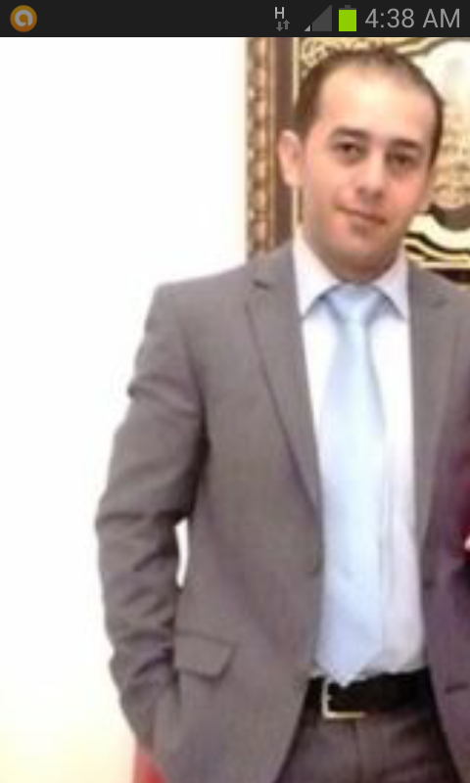 |    00971561984540

Karam.khawaja@gmail.com

Muslim

married

 | Sex :male | Date of birth 02-03-1983 | Nationality :Jordanian

JOB APPLIED FOR  POSITION  PREFERRED JOB  STUDIES APPLIED FOR | casing

WORK EXPERIENCE

EDUCATION | - Receptionist &Customer service –in Armed forces officer Club (Government)  In UAE – Abu Dhabi since: sep -2012 and I am still working  - Receptionist &call canter in jar aqamar company - Jordan –Amman from july-2005  To march -2008 3 years experience  - Receptionist & public relation in majestic hotel in Jordan –Amman form sep-1999  To may -2000
 | _______________________________________________________________________________
1-public relations management diploma in London academic- Abu Dhabi
2-human resources diploma in London academic UAE- Abu Dhabi
 | 3- 2003-2005: hotel and restaurant management university from-Jordan- Amman
TRAINING _ ______________________________________________________________________

1. Resolve training
2. Advanced equipment management
3 Answer and anticipate
4. Smile and greet
5. Talk and listen training
6. Grooming and hygiene
7.Be H.O.T
8-. Effective management practices
9- Advanced shift management
10-. HR rules
11- Basic shift management course

Objective | To obtain a challenging post at your reputable organization that will utilize both my educational background and professional experience to contribute to the organization's noble and humanitarian goals and er development and personal growth. An aspiring team worker, hard working and dedicated professional who wants to meet the challenges posed in the industry and to contribute towards the growth of the organization along with self-motivation | relevant

PERSONAL SKILLS
Communications’ and Organization Capabilities with low Supervision

Mother tongue(s) | ________________________________________________________________________________  Arabic language
Other language(s) | UNDERSTANDING |  | SPEAKING |  | WRITING
Other language(s) | Listening | Reading | Spoken interaction | Spoken production | good
Arabic | excellent | excellent | excellent | excellent | excellent
English | good | good | good | good | good
 | .

Communication skills | : Very good communication skills

Computer skills | : I have excellent printing and writing, correspondence and Internet use

Other skills | 1-good interpersonal skills  2-highyy disciplined and motivated individual with ability to work under pressure and minimum supervision

Driving licence | : UAE driving licence

